The complete genome of Cellulosimicrobium phage Cerberus

Ragd Elsaigh

ragd.elsaigh@gmail.com

ABSTRACT
This manuscript provides a novel account on the phage Cerberus, as well as its bacterial host and environmental background. In this paper, we provide preliminary sequencing data covering Cerberus’s genome, including structural gene annotations and functional protein predictions using various bioinformatics tools and analyses. Evidence is provided detailing the predicated functions, as well as the possible conclusions which can be drawn about our phage’s morphology, lifecycle, and regulatory mechanisms. Finally, we identify taxonomic comparisons and classifications of Cerberus to other related phages and discuss the significance of these results and the efficacy of the utilized bioinformatics tools in making these predictions.

Introduction
The phage Cerberus was isolated from the bacterial host Cellulosimicrobium, a gram-positive filamentous bacterium from the Promicromonosporaceae family (Loannou P et.al, 2024). This bacterium is commonly found in the environment in sewage and soil and is a pathogen although it rarely infects humans (ibid). Most reported cases are from immuno-compromised individuals with underlying medical conditions. The most lethal of these infections include bacteremia, infective endocarditis, and osteoarticular infections, which were commonly treated with vancomycin (ibid). This bacterial host has been found globally as infections have occurred in 7 patients from Asia, 14 patients from Europe, and 19 patients from America (ibid). Aside from clinical implications, this bacterial host has been found to cause microbial corrosion. Our sequenced phage Cerberus is of interest in this context as it has been found to infect this bacterial host and can have medical and environmental applications and benefits.

Methods
Phage Cerberus was isolated from Sabertooth park lake front, Fremont, CA, it was sequenced at Seqcenter (Pittsburgh, PA) as paired-end 150 bp reads. Sequence reads quality was controlled with FastQC then phage genome was assembled using SPAdes v3.5.0. The ATCC catalog number for Cerberus’s host strain is 12830. DNA was purified as previously described in (J.B, n.d). Finally, the phage genome was annotated using the Galaxy annotation pipeline as described previously in (Ramsey et.al).

Basic Genome Statistics
Cerberus has a genome length of 59992 bp with 236 K-mer coverage and a G+C content of .68. There are 98 annotated protein-coding genes, and no t-RNAs. There are no recorded interrupted genes or frameshifts. Additionally, there are no genes that have been split in half due to the initial opening of the genome, and since the phage Cerberus has no closely related phages that have been classified, there is no precedence for synteny matching and thus there is no need to reopen the genome.

Taxonomic Placement
Phage Cerberus is not part of an existing genus, as BLASTn, BLASTp, and pairwise percentage identity nucleotide analyses have returned insignificant percent identity scores or Dice Coefficients, this shows very little relatedness between Cerberus and other Caudoviricetes in terms of genome and protein sequence. Percent identity scores were below 6% and Dice Coefficients were all below .0582. A secondary taxonomic placement test was ran using NCBI BLASTn of Cerberus’s genome against Caudoviricetes sp.(taxid:2832643), and this revealed a singular 84.89% identity to Caudoviricetes sp. isolate MSP0819 (accession number OR222161), with a significant e-value of 7e-29. This result indicates both phages being potentially members of the same genus, however isolate MSP0819, has not been classified into any genus or species, and all that was found taxonomically, was that they shared the class Caudoviricetes. Thus, both phages could potentially be novel founders of a new genus.

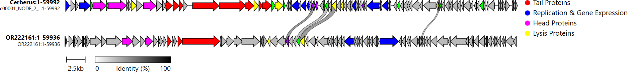
Figure 1. Genomic map of Cerberus(top) with BLAST relative OR222161(bottom)

In Figure 1. Major gene clusters are identified using a colored legend. Minor proteins such as hypothetical proteins(grey), transmembrane proteins (green), and various metabolism and regulatory genes (dark purple) have also been marked. There exists a general synteny between the two phages in the organization of their genes such as the head (pink), tail (red), replication (blue), and some lysis (yellow) and regulatory genes (dark purple). There are even some homologous genes with considerable percentage identity matches that have been mapped together. This lends to the relatedness of the two phages and adds some evidence to the aforementioned BLAST relatedness results. However, as both phages are novel and have no family identified, they can potentially be grouped together as part of the same family and even genus under the Caudovircetes class.

Genome Analysis

Phage Cerberus is predicted to be a siphophage, due to the identified tail components which are listed below with corresponding prediction evidence. This evidence consists of BLAST hits to similarly annotated proteins with significant e-values and overlap in sequence. These proteins include a tape measure protein(1.05937e-10), tail completion protein (5.07606e-15), head-to-tail adapter protein (5.42423e-33), tail fiber protein (3.65923e-05), and general major tail protein (1.22314e-28) and minor tail protein (4.3435e-14) components all within the same module (see Figure 1). There was no significance evidence of proteins with function of a contractile tail tube, tail sheath, or any baseplate components, all which are characteristic of myophages. The identification of the aforementioned tape measure protein was confirmed using Quick2D, where the composition was primarily alpha-helical. A few introns have been found within the tape measure protein, however no interrupted genes or chaperone frameshifts have been detected.
Some of these proteins were run through AlphaFold3 to determine a protein structure and further confirm protein function predictions. The structures with the highest scores are included below in Figures 2-4. Most of these proteins were of a great size, with over 200 residues, and thus they performed poorly on the FoldSeek database, often returning no significant results. Overall, this approach was less efficient and accurate than utilizing InterProScan, HHpred, and BLAST, because of the constraints on the length of the protein and its number of residues. This has resulted in limited prediction capabilities and led to extended processing times for each sequence. For instance, many of the proteins, which were predicted with high scores in BLAST and InterProScan to other functionally annotated proteins, returned hypothetical or unknown function when ran through these databases. This cost when compared to the overall poor prediction results and low confidence scores, places InterProScan, SwissProt, BLAST, and HHpred on a better performing level, as they provide more data and comparative information to draw predictions from in a relatively less tedious and short amount of time.

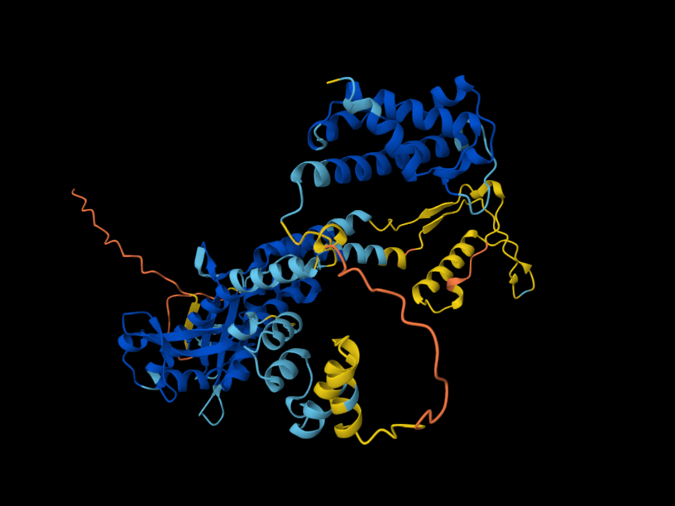
Figure 2: portal protein (gene coordinates: 3625-5425), 595 amino acid residues, ipTM = - pTM = 0.59

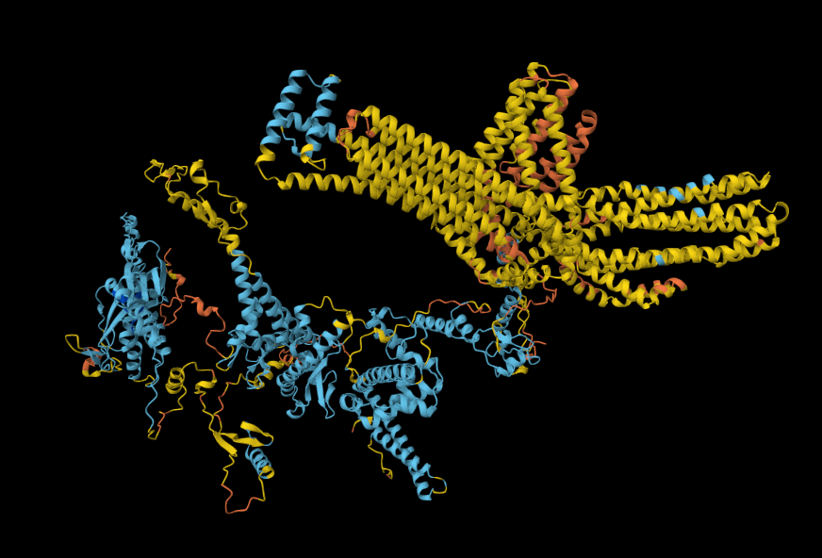
Figure 3: tape measure protein (gene coordinates: 16854-20391), 1175 amino acid residues, ipTM = .19 pTM = 0.28
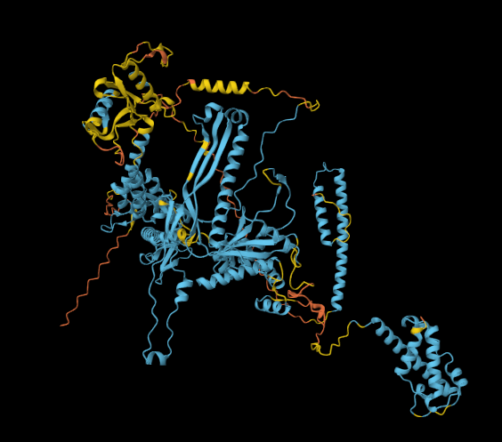
Figure 4: major capsid protein (gene coordinates: 10341-12019), 555 amino acid residues, ipTM = .12 pTM = 0.32

There are 98 annotated protein-coding genes in phage Cerberus’s genome. Most annotated proteins are either matched to pre-existing annotated proteins from the utilized bioinformatical databases (listed above) or are hypothetical, there are no novel proteins that have been recorded. Multiple transmembrane proteins have been identified via high TMHMM probability scores. Below is a list of major functional proteins, along with the evidence for their annotation. All e-values are sources are from BLAST results and contain significant overlap with their corresponding sequences. Other evidence includes considerable overlap with SwissProt, InterProScan, and/or conserved domain database matches.
Phage Cerberus is a virulent phage with a lytic lifestyle, there has been no evidence of lysogenic functioning genes within its genome. However, a number of proteins that aid in lysis have been annotated. These include Concavalin A-like lectin/glucanase (InterProScan match), peptidoglycan-recognition protein, and endolysins such as N-acetylmuramyl-L-alanine amidase, Lysin A (conserved domain), and autolysin. All of which have an InterProScan match and a major overlap in BLAST with an e-value of 1.3069e-25. Some other lysis proteins that have been identified include a lipoprotein signal protein (InterProScan match, LipoP SPII predicted cleavage site), phosphoesterase (SwissProt, InterProScan, conserved domain match, BLAST 5.43579e-09), and pyro-phosphohydrolase (InterProScan match, BLAST 5.57772e-12).
Additionally, a few replication and gene expression proteins have been annotated. These include ParB-like chromosome partitioning and nucleoid occlusion protein, with DNA-binding domains and nuclease activity. Evidence of this annotation includes SwissProt match, BLAST e-value score of 4.605e-10, and InterProScan prediction match. Other proteins include holliday junction resolvase/RusA-like endodeoxyribonuclease (InterProScan match, BLAST 8.78531e-15), helix-turn-helix DNA binding protein (BLAST e-value score 2.88266e-31), terminase (BLAST 1.10085e-160, InterProScan match), exonuclease (BLAST 4.74709e-41), double-strand break repair protein/DNA recombinase (BLAST 6.22023e-09, InterProScan match), single-stranded DNA binding proteins (InterProScan, SwissProt, conserved domain match, BLAST 4.99131e-32) and a DNA primase/polymerase/helicase with AAA domain (BLAST 1.28346e-17, SwissProt, InterProScan match).
Some head structural proteins include a portal protein (BLAST 3.1172e-150), minor head protein/capsid maturation protease/ head morphogenesis protein( BLAST 5.54964e-93), and a major capsid protein (BLAST 1.018e-92).
Finally, some annotated regulatory proteins include: HNH endonuclease (BLAST 1.09946e-13, InterProScan match), and superinfection exclusion protein (InterProScan, SwissProt, conserved domain match, BLAST 5.08801e-11).
Some expected genes that could not be definitively identified include the holins, these could have potentially been annotated as part of the hypothetical genes which are dispersed within the lysis cassette shown above in Figure 1 (yellow). However, an interesting tumor necrosis factor domain has been identified by a InterProScan match on one of the hypothetical proteins, and is believed to play a role in host cell death.
As is illustrated in the genomic map in Figure 1, there exists a distinct structural module organization in the phage’s genes which also line up with the most probable relative of phage Cerberus. These follow the order of replication genes, structural head component encoding genes, tail protein encoding genes, lysis genes, and finally some regulatory genes, with numerous hypothetical protein encoding genes and transmembrane protein including genes in between. Specifically, both phages have their tape measure protein and chaperones (red) in the same area, they also have head structural protein genes directly upstream and some regulatory and lysis genes directly downstream.

References

Clinker & clustermap.js: Automatic generation of gene cluster comparison figures Cameron L.M. Gilchrist, Yit-Heng Chooi Bioinformatics. doi: https://doi.org/10.1093/bioinformatics/btab007

Loannou P, Vorria A, Samonis G. Cellulosimicrobium Infections in Humans-A Narrative Review. Antibiotics (Basel). 2024 Jun 16;13(6):562. doi: 10.3390/antibiotics13060562. PMID: 38927228; PMCID: PMC11201038

A Completely Reimplemented MPI Bioinformatics Toolkit with a New HHpred Server at its Core.
Zimmermann L, Stephens A, Nam SZ, Rau D, Kübler J, Lozajic M, Gabler F, Söding J, Lupas AN, Alva V. J Mol Biol. 2018 Jul 20. S0022-2836(17)30587-9.
Clinker & clustermap.js: Automatic generation of gene cluster comparison figures Cameron L.M. Gilchrist, Yit-Heng Chooi Bioinformatics. doi: https://doi.org/10.1093/bioinformatics/btab007
Van Kempen M, Kim S, Tumescheit C, Mirdita M, Lee J, Gilchrist CLM, Söding J, and Steinegger M. Fast and accurate protein structure search with Foldseek. Nature Biotechnology, 2023.
Ramsey J;Rasche H;Maughmer C;Criscione A;Mijalis E;Liu M;Hu JC;Young R;Gill JJ; (n.d.-a). Galaxy and Apollo as a biologist-friendly interface for high-quality cooperative phage genome annotation. PLoS computational biology. https://pubmed.ncbi.nlm.nih.gov/33137082

TMHMM: Predicting transmembrane protein topology with a hidden Markov model: application to complete genomes.
Krogh A, Larsson B, von Heijne G, Sonnhammer EL. J Mol Biol. 2001 Jan 19;305(3):567-80.

Van Kempen M, Kim S, Tumescheit C, Mirdita M, Lee J, Gilchrist CLM, Söding J, and Steinegger M. Fast and accurate protein structure search with Foldseek. Nature Biotechnology, 2023.

J, B. J. M. J. (n.d.). Phage DNA extraction, genome assembly, and genome closure. Methods in molecular biology (Clifton, N.J.). https://pubmed.ncbi.nlm.nih.gov/37966596

Ramsey J;Rasche H;Maughmer C;Criscione A;Mijalis E;Liu M;Hu JC;Young R;Gill JJ; (n.d.-a). Galaxy and Apollo as a biologist-friendly interface for high-quality cooperative phage genome annotation. PLoS computational biology. https://pubmed.ncbi.nlm.nih.gov/33137082

Methods Tools:
- http://www.bioinformatics.babraham.ac.uk/projects/fastqc

- For referencing data from Cellulosimicrobium strain: doi:10.13145/bacdive12575.20250331.9.3
- BacDive: doi: 10.1093/nar/gkab961

